SUKI’S KIMONO: A LESSON PLAN

Date: Early in the school year
Time: Last learning block of the day Class: Kindergarten
Duration: 30 minutes School: Rivers Edge School

***********************************************************************************************************************

Developmental domains: Aesthetic, cognitive, emotional, language, physical, social
Objectives (curriculum domains): Language and literacy, social studies, art

By the end of this lesson, students will be able to recognize that people are different and that they come from different backgrounds. They will also be able to show evidence that they accept/appreciate diversity, and to state that rejecting people who are different is hurtful.

Group size: 20-25 kids
Materials:
● Suki’s Kimono, by Chieri Uegaki
● Contruction paper of all colours, cut in shapes of people (see p. 4 for template)
● White paper cut in shapes of shirts, pants, skirts (see p. 5 for templates)
● Pipe cleaners in all colours
● Crayons, glue, safety scissors

Professional competencies:
-To act as a professional inheritor, critic and interpreter of knowledge or culture when teaching
students.
-To communicate clearly in the language of instruction, both orally and in writing, using correct
grammar, in various contexts related to teaching.
-To develop teaching/learning situations that are appropriate to the students concerned and the
subject content with a view to developing the competencies targeted in the programs of study.
-To plan, organize, and supervise a class in such a way as to promote students’ learning and social
development.
-To demonstrate ethical and responsible professional behaviour in the performance of his or her
duties

TIME | ACTIVITY
2 minutes  8 minutes  5 minutes  15 minutes | Introduction  This activity will foster student engagement and interest by connecting the story with an event that  they have experienced (the start of kindergarten).  ● Teacher will introduce Suki’s Kimono by first asking students, “Do you  remember your first day of kindergarten? How did you feel when you first  arrived at the school?”  ● Students will respond by sharing how they felt.  ● Teacher will explain that Suki’s Kimono is the story of a girl who starts her first  day of school, in the same way they did at the beginning of the year.  Development  During this activity, teacher and students read Suki’s Kimono and engage in a constructivist  group discussion about diversity.  ● Teacher will read Suki’s Kimono.  ● Teacher will engage the students in a group discussion, guided by the following  questions: “Why do you think the other kids were laughing at Suki?” “How do  you think that made Suki feel?” “How can we be nice to people who seem  different from us, so that they feel happy and accepted?”  Closure/Transition  This activity will reinforce the idea that people are different and that diversity is a positive thing.  ● Teacher will explain that all the students in the class are different and unique,  and that this is a good thing. “In fact, I think that each of you is so special and  wonderful that I would like to have a model of everyone on the bulletin board.”  ● Teacher will explain that students will be able to make a “mini-version” of  themselves, and that they can decorate themselves any way they like, just as  Suki dressed herself the way she liked.  ● Students will choose paper people in the colour they feel represents them, along  with clothes and hair.  ● Students will glue the clothes and hair on the paper person, draw in the face,  and decorate the clothes.  ● Teacher will collect the completed paper people to be pinned up on the bulletin  board later. The paper people will be pinned up holding hands.  ● Students will put the crayons, glue and scissors away.  Evaluation  Students will be evaluated informally based on several criteria.  ● Focus during storytime: Level of engagement with the text and the pictures,  frequency of remarks or questions.  ● Participation in group discussion: Level of engagement, quality of contributions,  effort to listen to classmates and to take turns, ability to understand the story,  ability to understand and appreciate the concept of diversity.  ● Participation in art activity: Level of engagement, effort to produce an  aesthetically pleasing paper person, respect for others’ work and space, ability  to manipulate art supplies and materials to accomplish goals.  What’s next? (Development/Extensions)  Please refer to page 6 for web of ideas

TEMPLATE 1: PAPER PERSON

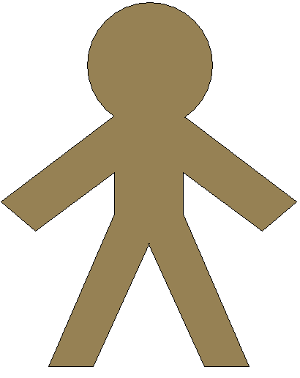
A paper person, in one of many colours.

TEMPLATE 2: PAPER SHIRT, PANTS AND SKIRT

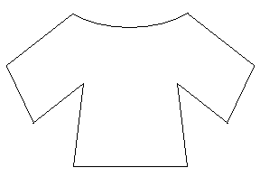
A shirt

Pants
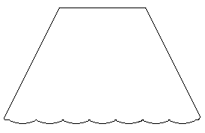

A skirt

